МІНІСТЕРСТВО ОСВІТИ І НАУКИ УКРАЇНИ

Національний технічний університет

«Харківський політехнічний інститут»

Факультет Комп’ютерних наук та програмної інженерії

Кафедра Інформатики та інтелектуальної власності

ЗВІТИ

До лабораторних робіт з дисципліни

«Основи WEB технологій»

Студент Карауланов А.О.

Викладач Івашко А.В.

Харків 2022

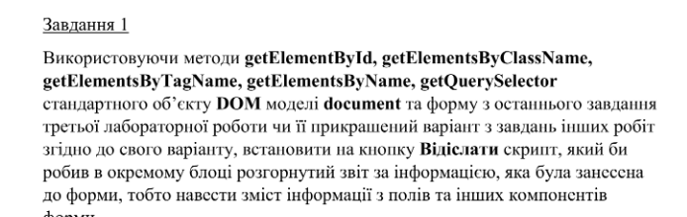

function Task1() {

let inputs=document.getElementsByTagName("input");

let selects=document.getElementsByTagName("select");

let t =document.getElementsByClassName("radiobutton");

let more=document.getElementsByTagName("textarea");

let res=`Контактна інформація:

Ім'я:${inputs[0].value}

Телефон:${inputs[1].value}

Пошта:${inputs[2].value}

Відвідування:${inputs[3].value}

Персональна інформація

Вік:${selects[0].value}

Улюблена кухня:${selects[1].value}

Які страви хотіли б побачити:${more[0].value}

Оцінка установи\n`;

Array.from(t).forEach(e => {

if (e.labels!=null&&e.checked) {

res+=`${e.labels[0].innerText}\n`;

}

});

alert(res);

}

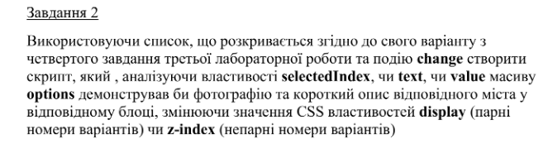

let list=document.getElementById("city")

list.onchange=function () {

Array.from(document.getElementsByClassName("box")).forEach(e => {

e.style.display="none"

});

document.getElementById(list.selectedIndex).style.display="block";

}

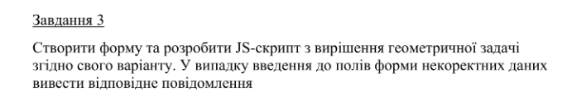

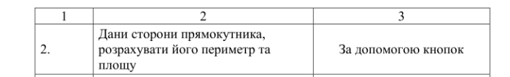

document.forms.calc.addEventListener('submit', (e) => {

e.preventDefault();

let a=document.getElementById("length").value;

let b=document.getElementById("width").value;

console.log();

if (a<=0||b<=0) {

alert("Incorrect values!");

return;

}

switch (e.submitter.id) {

case "P":

alert((Number(a)+Number(b))*2);

break;

case "S":

alert(a*b);

break;

}

});

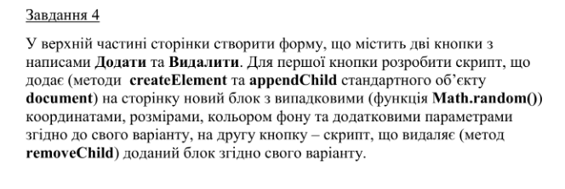



document.getElementById("add").onclick = () => {

console.log(1);

div = document.createElement("div");

div.style.position = "absolute";

div.style.top=String(getRandomInt(500))+"px";

div.style.left = String(getRandomInt(500))+"px";

div.style.width = String(getRandomInt(300))+"px";

div.style.height = String(getRandomInt(100))+"px";

div.style.backgroundColor = `rgb(${getRandomInt(255)}, ${getRandomInt(255)}, ${getRandomInt(255)})`;

div.innerHTML=getRandomInt(10000)

document.getElementsByTagName("body")[0].appendChild(div);

}

document.getElementById("rm").onclick = () => {

document.getElementsByTagName("body")[0].removeChild(document.getElementsByTagName("body")[0].lastChild);

}

function getRandomInt(max) {

return Math.floor(Math.random() * max);

}

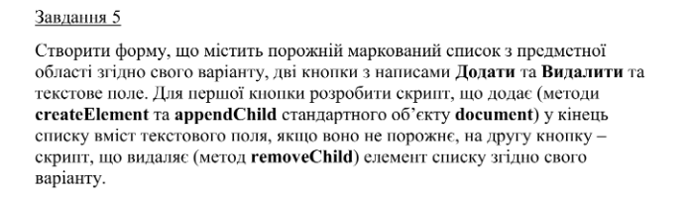

document.getElementById("add").onclick=()=>{

li=document.createElement("li");

let arg=document.getElementById("arg").value;

if (arg=="") {

return

}

document.getElementById("arg").value="";

li.innerHTML=arg;

document.getElementById("list").appendChild(li);

}

document.getElementById("rm").onclick=()=>{

document.getElementById("list").removeChild(document.getElementById("list").lastChild);

}

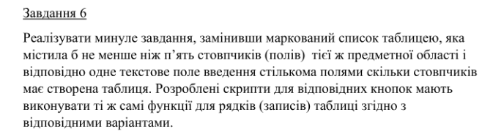

document.getElementById("add").onclick=()=>{

tr=document.createElement("tr");

let country=document.getElementById("country").value;

let age=document.getElementById("age").value;

let genre=document.getElementById("genre").value;

let surname=document.getElementById("surname").value;

let notes=document.getElementById("notes").value;

if (country==""||age==""||genre==""||surname=="") {

alert("Заповніть усі поля!");

return;

}

tr.innerHTML=`<td>${country}</td>

<td>${age}</td>

<td>${genre}</td>

<td>${surname}</td>

<td>${notes}</td>`;

document.getElementById("list").appendChild(tr);

}

document.getElementById("rm").onclick=()=>{

if (document.getElementById("list").childElementCount==1) {

return;

}

document.getElementById("list").removeChild(document.getElementById("list").lastChild);

}

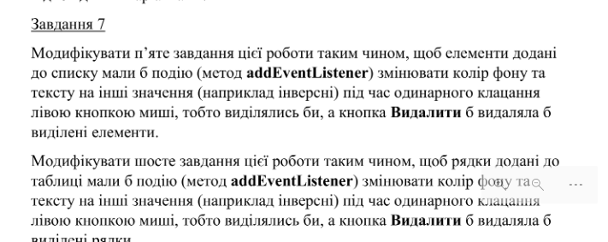

document.getElementById("add").onclick=()=>{

li=document.createElement("li");

let arg=document.getElementById("arg").value;

if (arg=="") {

return

}

document.getElementById("arg").value="";

li.innerHTML=arg;

document.getElementById("list").appendChild(li);

}

document.getElementById("list").addEventListener("click", (event)=>{

let target=event.target;

if (target.tagName!="LI") {

return;

}

target.style.backgroundColor="black";

target.style.color="white";

target.className="toRm"

});

document.getElementById("rm").onclick=()=>{

let l=document.getElementById("list").children;

if (l==null) {

return;

}

for (let item of l) {

if (item.className=="toRm") {

item.remove();

}

}

}

document.getElementById("add").onclick=()=>{

tr=document.createElement("tr");

let country=document.getElementById("country").value;

let age=document.getElementById("age").value;

let genre=document.getElementById("genre").value;

let surname=document.getElementById("surname").value;

let notes=document.getElementById("notes").value;

if (country==""||age==""||genre==""||surname=="") {

alert("Заповніть усі поля!");

return;

}

tr.innerHTML=`<td>${country}</td>

<td>${age}</td>

<td>${genre}</td>

<td>${surname}</td>

<td>${notes}</td>`;

document.getElementById("list").appendChild(tr);

}

document.getElementById("rm").onclick=()=>{

let l=document.getElementById("list").children;

if (l==null) {

return;

}

for (let item of l) {

if (item.className=="toRm") {

item.remove();

}

}

}

document.getElementById("list").addEventListener("click", (event)=>{

let target=event.target;

while (target.tagName!="TR") {

target=target.parentNode

}

if (target.tagName=="TD") {

target=target.parentNode

}else if(target.tagName!="TR"){

return

}

target.style.backgroundColor="black";

target.style.color="white";

target.className="toRm"

});

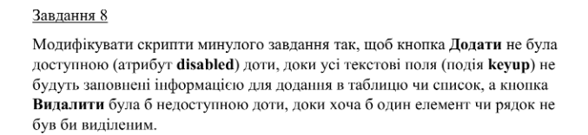

document.getElementById("add").onclick=()=>{

li=document.createElement("li");

let arg=document.getElementById("arg").value;

if (arg=="") {

return

}

document.getElementById("arg").value="";

li.innerHTML=arg;

document.getElementById("list").appendChild(li);

document.getElementById("add").disabled=true;

}

document.getElementById("list").addEventListener("click", (event)=>{

let target=event.target;

if (target.tagName!="LI") {

return;

}

target.style.backgroundColor="black";

target.style.color="white";

target.className="toRm"

document.getElementById("rm").disabled=false;

});

document.getElementById("arg").onkeyup=()=>{

if (document.getElementById("arg").value=="") {

document.getElementById("add").disabled=true;

}else{

document.getElementById("add").disabled=false;

}

}

document.getElementById("rm").onclick=()=>{

let l=document.getElementById("list").children;

if (l==null) {

return;

}

for (let item of l) {

if (item.className=="toRm") {

item.remove();

}

}

document.getElementById("rm").disabled=true;

}

document.getElementById("add").onclick = () => {

tr = document.createElement("tr");

let country = document.getElementById("country").value;

let age = document.getElementById("age").value;

let genre = document.getElementById("genre").value;

let surname = document.getElementById("surname").value;

let notes = document.getElementById("notes").value;

if (country == "" || age == "" || genre == "" || surname == "") {

alert("Заповніть усі поля!");

return;

}

tr.innerHTML = `<td>${country}</td>

<td>${age}</td>

<td>${genre}</td>

<td>${surname}</td>

<td>${notes}</td>`;

document.getElementById("list").appendChild(tr);

}

document.getElementById("rm").onclick = () => {

let l = document.getElementById("list").children;

if (l == null) {

return;

}

for (let item of l) {

if (item.className == "toRm") {

item.remove();

}

}

if (document.getElementsByClassName("toRm").length==0) {

document.getElementById("rm").disabled = true;

}else{

document.getElementById("rm").disabled = false;

}

}

document.getElementById("list").addEventListener("click", (event) => {

let target = event.target;

while (target.tagName != "TR") {

target = target.parentNode

}

if (target.tagName == "TD") {

target = target.parentNode

} else if (target.tagName != "TR") {

return

}

target.style.backgroundColor = "black";

target.style.color = "white";

target.className = "toRm";

if (document.getElementsByClassName("toRm").length==0) {

document.getElementById("rm").disabled = true;

}else{

document.getElementById("rm").disabled = false;

}

});

document.getElementById("container").addEventListener("keyup", (event) => {

let target = event.target;

for (let item of document.getElementById("container").getElementsByTagName("input")) {

if (item.value == "") {

document.getElementById("add").disabled = true;

return;

}

document.getElementById("add").disabled = false;

}

});

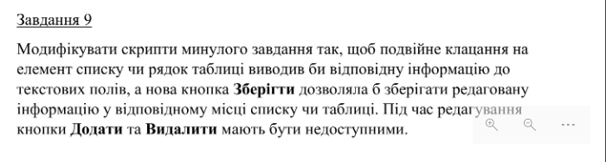

document.getElementById("add").onclick = () => {

li = document.createElement("li");

let arg = document.getElementById("arg").value;

if (arg == "") {

return

}

document.getElementById("arg").value = "";

li.innerHTML = arg;

document.getElementById("list").appendChild(li);

document.getElementById("add").disabled = true;

}

document.getElementById("list").addEventListener("click", (event) => {

let target = event.target;

if (target.tagName != "LI") {

return;

}

target.style.backgroundColor = "black";

target.style.color = "white";

target.className = "toRm"

document.getElementById("rm").disabled = false;

});

document.getElementById("list").addEventListener("dblclick", (event) => {

let target = event.target;

if (target.tagName != "LI") {

return;

}

target.className = "toEdit"

document.getElementById("arg").value = target.textContent;

document.getElementById("rm").disabled = true;

document.getElementById("add").disabled = true;

document.getElementById("sv").disabled = false;

});

document.getElementById("arg").onkeyup = () => {

if (document.getElementById("arg").value == ""||document.getElementById("sv").disabled == false) {

document.getElementById("add").disabled = true;

} else {

document.getElementById("add").disabled = false;

}

}

document.getElementById("rm").onclick = () => {

let l = document.getElementById("list").children;

if (l == null) {

return;

}

for (let item of l) {

if (item.className == "toRm") {

item.remove();

}

}

document.getElementById("rm").disabled = true;

}

document.getElementById("sv").onclick = () => {

let l = document.getElementById("list").children;

if (l == null) {

return;

}

for (let item of l) {

if (item.className == "toEdit") {

item.textContent = document.getElementById("arg").value;

item.style.color="black";

item.style.backgroundColor="white";

item.className="";

}

}

document.getElementById("sv").disabled = true;

}

document.getElementById("add").onclick = () => {

tr = document.createElement("tr");

let country = document.getElementById("country").value;

let age = document.getElementById("age").value;

let genre = document.getElementById("genre").value;

let surname = document.getElementById("surname").value;

let notes = document.getElementById("notes").value;

if (country == "" || age == "" || genre == "" || surname == "") {

alert("Заповніть усі поля!");

return;

}

tr.innerHTML = `<td>${country}</td>

<td>${age}</td>

<td>${genre}</td>

<td>${surname}</td>

<td>${notes}</td>`;

document.getElementById("list").appendChild(tr);

}

document.getElementById("rm").onclick = () => {

let l = document.getElementById("list").children;

if (l == null) {

return;

}

for (let item of l) {

if (item.className == "toRm") {

item.remove();

}

}

if (document.getElementsByClassName("toRm").length==0) {

document.getElementById("rm").disabled = true;

}else{

document.getElementById("rm").disabled = false;

}

}

document.getElementById("list").addEventListener("click", (event) => {

let target = event.target;

while (target.tagName != "TR") {

target = target.parentNode

}

if (target.tagName == "TD") {

target = target.parentNode

} else if (target.tagName != "TR") {

return

}

target.style.backgroundColor = "black";

target.style.color = "white";

target.className = "toRm";

if (document.getElementsByClassName("toRm").length==0) {

document.getElementById("rm").disabled = true;

}else{

document.getElementById("rm").disabled = false;

}

});

document.getElementById("list").addEventListener("dblclick", (event) => {

let target = event.target;

while (target.tagName != "TR") {

target = target.parentNode

}

if (target.tagName == "TD") {

target = target.parentNode

} else if (target.tagName != "TR") {

return

}

let arr=[];

console.log(target.children);

for (e of target.children) {

arr.push(e.innerHTML);

}

target.className="toEdit";

document.getElementById("country").value=arr[0];

document.getElementById("age").value=arr[1];

document.getElementById("genre").value=arr[2];

document.getElementById("surname").value=arr[3];

document.getElementById("notes").value=arr[4];

document.getElementById("rm").disabled = true;

document.getElementById("add").disabled = true;

document.getElementById("sv").disabled = false;

});

document.getElementById("container").addEventListener("keyup", (event) => {

let target = event.target;

for (let item of document.getElementById("container").getElementsByTagName("input")) {

if (item.value == "") {

document.getElementById("add").disabled = true;

return;

}

document.getElementById("add").disabled = false;

}

});

document.getElementById("sv").onclick = () => {

let l = document.getElementById("list").children;

if (l == null) {

return;

}

for (let item of l) {

if (item.className == "toEdit") {

let arr=item.children;

arr[0].innerHTML=document.getElementById("country").value;

arr[1].innerHTML=document.getElementById("age").value;

arr[2].innerHTML=document.getElementById("genre").value;

arr[3].innerHTML=document.getElementById("surname").value;

arr[4].innerHTML=document.getElementById("notes").value;

item.style.color="black";

item.style.backgroundColor="white";

item.className="";

}

}

document.getElementById("sv").disabled = true;

}

**Висновок**

На цій лабораторній роботі на практиці було засвоєно просте використання Java скриптів.